**Trigonometric identities**:

sin (A±B) = sin(A)cos(B) ± cos(A)sin(B)

cos (A±B) = cos(A)cos(B) ∓ sin(A)sin(B)

tan (A±B) = $\frac{\tan\left(A\right)±tan⁡(B)}{1∓\tan\left(A\right)tan⁡(B)}$

**It’s a relation and not a function because it isn’t one-to-one (for most values of $x$ there is more than one value of $y$).**

**It’s a function and not a relation because it is a one-to-one (for most values of $x$ there is more than one value of $y$).**

**Line A and Line B in the x-y plane intersect at 90° at the origin. Line A has a slope of $\frac{1}{3}$. Point (2, –6) is the midpoint of line segment CD which is parallel to Line A. Given that the x-value of C is –1, find the coordinates of point D.**

2 = 🡪 x = 5

= –6 🡪 y2 + y1 = –12

= = = 🡪 y2 – y1 = 2

y2 + y1 = –12

P(D) = (5, –5)

2y2 = –10 🡪 y2 = –5

y2 – y1 = 2

Use gradient: = 🡪 y2 – y1 = 2 🡪 –5 – y1 = 2 🡪 y1 = –7 🡪 P(C) = (–1, 7)

**The circle with centre A(5, 8) touches the 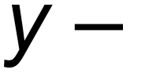axis as shown below.**

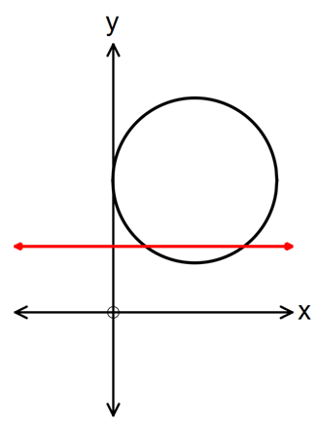

**The line y = 4 intersects the circle at point M and N.**

**[a] Determine the length of the chord MN.**

(x – 5)2 + (y – 8)2 = 25 🡪 substitute y = 4 🡪 x = 2, x=8 🡪 6 units

**[b] Find the area of the minor segment formed between MN and the circle.**

62 = 52 + 52 – 2 x 52 x cosθ 🡪 θ = 1.287 radians

x 52 x 1.287 – x 52 x sin(1.287) = 4.0875 units2

**The diagram below has an arc, PQ, of a circle with centre O and radius r.**

**PR is perpendicluar to OQ. Angle POQ = 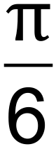 radians.**

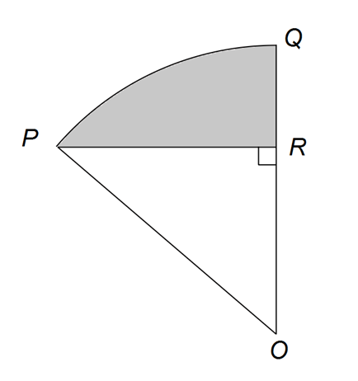

**[a] Show that the area of triangle POR = $\frac{r^{2}\sqrt{3}}{2}$ in terms of r. (Hint: First find expressions for OR and RR in terms of r).**

sin() = 🡪 PR = $\frac{r}{2}$

cos() = 🡪 OR = $\frac{r\sqrt{3}}{2}$

Triangle area = $\frac{1}{2}$ x $\frac{r\sqrt{3}}{2}$ x $\frac{r}{2}$ = $\frac{r^{2}\sqrt{3}}{8}$

**[b] If the shaded area is cm2, calculate the value of r.**

Shaded area = sector area – triangle area

= x r2 x –

CAS 🡪 r = 2, r = –2 (reject x = –2)

r = 2

**A sector OPQ of a circle with centre O is drawn below. The radius of the circle is 18 cm and angle POQ is 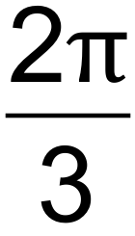 radians. The tangents to the circle at the points P and Q meet at point R. 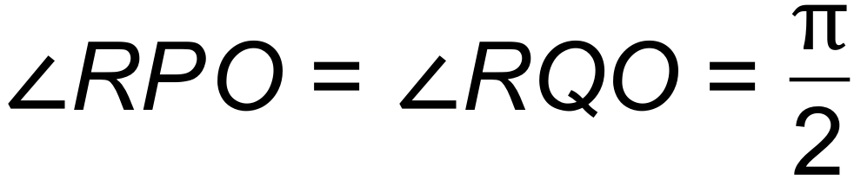. Find the exact area of the shaded region.**

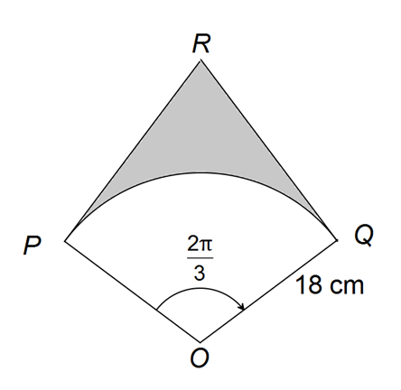

tan() = 🡪 PR = 18tan($\frac{π}{3}$)

Triangle area = $\frac{1}{2}$ bh = $\frac{1}{2}$ x 18 x 18tan($\frac{π}{3}$)

Kite area = 2 x $\frac{1}{2}$ x 18 x 18tan($\frac{π}{3}$) = 18 x 18tan($\frac{π}{3}$)

Sector area = x 182 x

Shaded area = (18 x 18tan()) – ( x 182 x ) = 324 – 108π = 108(3 $\sqrt{3}$– π)

**The graph of y = f(x) is shown below, where f(x) = is shown below, where f(x) = sin(x+c) and c is a constant.**

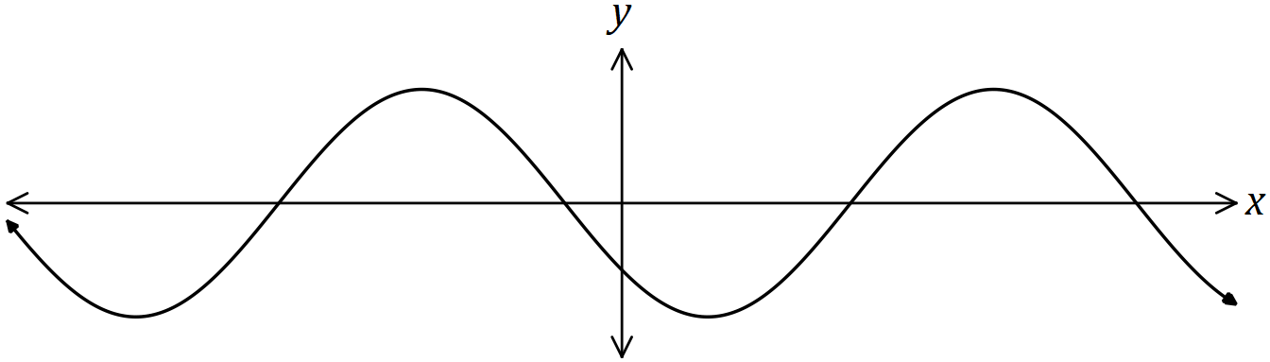

**Explain how to obtain the graph of each function below from the graph of f(x), given that a and b are also constants.**

**[a] y = sin(x+a).**

sin(x+c) 🡪 sin(x+a) Subtract c and add a.

sin(x+c–c+a) = sin(x+a)

sin(x+c–(x–a) = sin(x+a)

Translate horizontally by (c–a) units.

**[b] y = cos(x+b).**

sin(x+c) 🡪 cos(x+b)

sin(x+c) = cos(x+c $-\frac{π}{2}$) Subtract c and add b

cos(x+c+ $\frac{π}{2}$– c+b) = cos(x+b)

cos(x+c–($-\frac{π}{2}$ +c–b) = cos(x+b)

Translate horizontally by (c–b $-\frac{π}{2}$) units

**Complete the square to find the roots of the quadratic function f(x) = 5x2 – 7x + 1.**

5x2–7x + 1 = 5(x2 – x + )

= 5(x2 – x + – + )

= 5(x – )2 –

5(x – )2 =

(x – )2 = x =

x – = = ±

x = ± =